**Tools Combination Website**

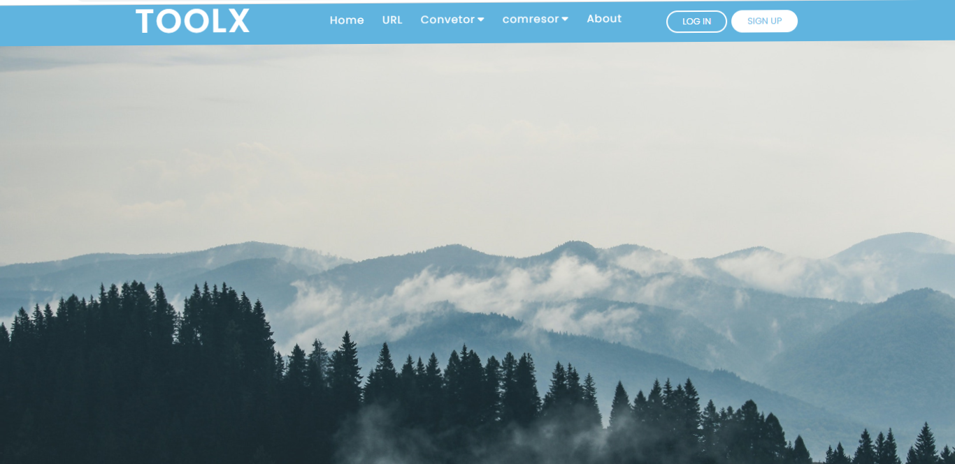

**Prepared by**

**Gaurav Jadav**

**Priyank Jivani**

**Guided by**

**Pratvi Lavingiya**

**Index**

Page title ………………………………………………………………………………....….………………………….…

Certificate of work ……………………………………………………………………………………….…………… i

Acknowledgment ……………………………………………………..………………………………………...…… ii

1. Chapter 1. **Introduction** …………………………………………………………………………………. 5
   1. Background ……………………………………………………………………... 6
   2. Objective ……………………………………………….…………………………. 8
   3. Purpose ………………………………….………………………………………… 9
   4. Scope …………………………………………………….…………………………. 10
2. Chapter 2. **Requirement And Analysis** ………………………………..……………………… 12
   1. Problem definition ………………………………………………….….…. 14
   2. Functional requirement ……………………………………………….. 16
   3. Hardware and Software ……….………………………………………. 17
   4. Planning and scheduling ……………………………….……………… 18

* **Project Name :-** Tools Combination
* **Project Type :-**  Web Application
* **Operating System :-** Windows 10
* **Hardware :-** i5 6400T CPU
* **Front End :-** PHP
* **Back End :-** My SQL
* **Internal Guide :-**
* **Project Duration :-** 3 Months
* **Developed By :-** Gaurav Jadav, Priyank Jivani
* **Submitted To :-**

Chapter :-1

Introduction

**POINTS**

1.1 Introduction

1.2 Background

1.3 Objective

1.4 Purpose

1.5 Scope

**Introduction**

* This All Project About The Combination Of The Different Website. We combine the website is URL shortner, convertor, compressor, and etc.

More tools are added.

* In URL shortner many one can short user url in this website. one line url can be shorted in some of words. And this shorted url can be stored in our database which can show using the admin panel login. And we can show the url which are shorted and also know the url how many time is redirect by user and we can delete, edit this url in admin penal.
* Convertor section all the user can convert the .pdf extension to another format like:-  **pdf 2 Word**, **Text 2 pdf**, **Image 2 pdf**, **html 2 pdf**, **Word 2 pdf, pdf 2 Excel, pdf 2 ppt**  etc. more given in this section. We can also convert images format like :-

**.gif**, **.jpeg**, **.png**, **.jpg** etc.

* In this we adding the admin penal to handle the all of the use data. and use more functionality in this section.

**Background**

* **Operating System** :- Windows 10
* **Technology Used** :-

1. **Front End**:- PHP
2. **Back End**:- MySQL

* **PHP :-**
* PHP started out as a small open source project that evolved as more and more people found out how useful it was. Rasmus Lerdorf unleashed the first version of PHP way back in 1994.
* PHP is an open-source, interpreted, and object-oriented scripting language that can be executed at the server-side. PHP is well suited for web development. Therefore, it is used to develop web applications (an application that executes on the server and generates the dynamic page.).
* PHP is a recursive acronym for "PHP: Hypertext Preprocessor".
* PHP Syntax is C-Like.
* PHP is a server side scripting language that is embedded in HTML. It is used to manage dynamic content, databases, session tracking, even build entire e-commerce sites.
* It is integrated with a number of popular databases, including MySQL, PostgreSQL, Oracle, Sybase, Informix, and Microsoft SQL Server.
* PHP supports a large number of major protocols such as POP3, IMAP, and LDAP. PHP4 added support for Java and distributed object architectures (COM and CORBA), making n-tier development a possibility for the first time.
* PHP is pleasingly zippy in its execution, especially when compiled as an Apache module on the Unix side. The MySQL server, once started, executes even very complex queries with huge result sets in record-setting time.
* **MySQL :-**
* MySQL, the most popular Open Source SQL database management system, is developed, distributed, and supported by Oracle Corporation.
* MySQL is a relational database management system (RDBMS) developed by oracle that is based on structure query language (SQL).
* MySQL is a fast, easy-to-use RDBMS being used for many small and big businesses. MySQL is developed, marketed and supported by MySQL AB, which is a Swedish company. MySQL is becoming so popular because of many good reasons
* MySQL is released under an open-source license. So you have nothing to pay to use it.
* MySQL is a very powerful program in its own right. It handles a large subset of the functionality of the most expensive and powerful database packages.
* MySQL uses a standard form of the well-known SQL data language.
* MySQL works on many operating systems and with many languages including PHP, PERL, C, C++, JAVA, etc.
* MySQL works very quickly and works well even with large data sets.
* MySQL is very friendly to PHP, the most appreciated language for web development.
* MySQL supports large databases, up to 50 million rows or more in a table. The default file size limit for a table is 4GB, but you can increase this (if your operating system can handle it) to a theoretical limit of 8 million terabytes (TB).
* MySQL is easy to use, yet extremely powerful, fast, secure, and scalable.
* MySQL is ideal database solution for both small and large applications.
* MySQL includes data security layers that protect sensitive data from intruders.
* MySQL is customizable. The open-source GPL license allows programmers to modify the MySQL software to fit their own specific environments.

**Objective**

* The objective of the project is to make a great web combination for the users and do their own work at one platform in less time and efforts.
* User can use this website as a open-source and free platform using this website. Using this website the user can save their time because we provide the web combination of the url shortner, pdf converter, image converter, pdf compressor, image compressor, and many more type of the combinations.

* This open-source project would be focus on free software which can use by everyone free of cost.
* This is work as faster as the other websites and time saver and get more then functionality in this combine website.
* **The tools combination website has many objective some of them as follow:**
* URL shortner spit out links that are easier to share. More importantly, they let small businesses track marketing campaigns and other incoming traffic.
* Text to pdf is a use to any text converter in to pdf and you can easily share with your friends and company. Text to pdf helpful to create any text into pdf.
* html to pdf is convert html code into web view and convert direct in pdf and easily download pdf.
* You can also compress your pdf. if any pdf file is more than 2mb then you can easily compress size into 1mb and download it.

**Purpose**

* In this project we follow the Software Development Life Cycle (SDLC). Methodologies use to develop website. I have used Waterfall Model to develop this website.
* The main steps in this methodology are requirement, Analysis, Design, Implementation, Testing and Maintenance.
* The waterfall model is also called as liner sequential model, in this model all tasks are completed one by one. To use this model this model the major advantage is very simple and all project development process takes place as per the user requirement
* A URL shortner is an online tool that allows you to enter a long URL and receive a shortened version in return. It seems overly simple, but that’s the reality. There are some free link shortner and some that you would have to pay for, but, either way, short URLs will work in your favor.
* PDFs are essential for digital businesses to quickly share project information, ensuring the whole team works together. And using the best PDF converters makes it simple to do everyday tasks productively.
* We all are pretty acquainted with image compression. Image compression means reducing the size of an image. We can reduce the size of the image without losing its quality.
* Whenever someone uploads pictures in social media or takes a snapshot and upload somewhere or upload our degree certificates, we compress images.

**Scope**

* This website is basically for server and deployed on the server site.
* The tools combination website is basically useful to random users to reduce its work.
* User can save their time.
* User can use this website as open-source.
* It takes less time and efforts.
* In this website provide that how to use this.
* Get more then functionality then the other websites.
* More flexible.
* people can short url from any place through(via) internet
* **This website will be use full for following areas:**
* Useful for shorting the url to users.
* Using this website many one can convert his image or pfd format.
* In this we adding the compressor feature to compressor the size.
* This website can reduce most of work and save the time to every user.

Chapter :- 2

Requirement and Analysis

**POINTS**

2.1 Requirement and analysis

2.2 Problem Definition

2.3 Functional Requirement

2.4 Hardware and Software

2.5 Planning and Scheduling

**Requirement And Analysis**

Requirement analysis is significant and essential activity after elicitation. We analyze, refine, and scrutinize the gathered requirements to make consistent and unambiguous requirements. This activity reviews all requirements and may provide a graphical view of the entire system. After the completion of the analysis, it is expected that the understandability of the project may improve significantly. Here, we may also use the interaction with the customer to clarify points of confusion and to understand which requirements are more important than others.

* **The various steps of requirement analysis are shown in fig:**

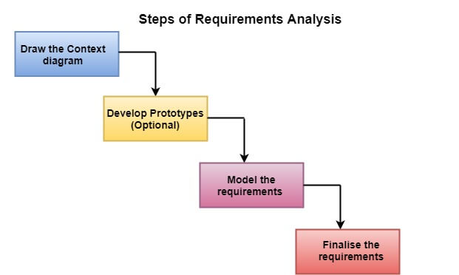

1. **Draw the context diagram :-**

The context diagram is a simple model that defines the boundaries and interfaces of the proposed systems with the external world. It identifies the entities outside the proposed system that interact with the system.

1. **Development of a Prototype (optional) :-**

One effective way to find out what the customer wants is to construct a prototype, something that looks and preferably acts as part of the system they say they want.

We can use their feedback to modify the prototype until the customer is satisfied continuously. Hence, the prototype helps the client to visualize the proposed system and increase the understanding of the requirements. When developers and users are not sure about some of the elements, a prototype may help both the parties to take a final decision.

Some projects are developed for the general market. In such cases, the prototype should be shown to some representative sample of the population of potential purchasers. Even though a person who tries out a prototype may not buy the final system, but their feedback may allow us to make the product more attractive to others.

1. **Model the requirements :-**

This process usually consists of various graphical representations of the functions, data entities, external entities, and the relationships between them. The graphical view may help to find incorrect, inconsistent, missing, and superfluous requirements. Such models include the Data Flow diagram, Entity-Relationship diagram, Data Dictionaries, State-transition diagrams, etc.

1. **Finalist the requirements :-**

After modeling the requirements, we will have a better understanding of the system behavior. The inconsistencies and ambiguities have been identified and corrected. The flow of data amongst various modules has been analyzed. Elicitation and analyze activities have provided better insight into the system. Now we finalize the analyzed requirements, and the next step is to document these requirements in a prescribed format.

**Problem Definition**

* **Problem Of Old System**

1. Require to long procedure to be completed (manual queue procedure).
2. Not Interactive.
3. High probability of errors.
4. Difficult to use further (searching).
5. Provide less functionality.
6. This type of system is also become more complicated for admin to handle all the data of different user us per their requirement.

* **To solve Problem New System**
  1. **Quality requirement** :-
     + The quality in software development process is by periodic reviews documentation and verification at all appropriate stages.
     + Software engineering standards should be followed throughout the development process. The quality attribute in the software package.
  2. **Readability :-**
     + Appropriate comment in the project source code will be provided for readability so that the user can easily read and understand the project if need be.
     + So that project will be helpful for interested person. The application should be functionally correct as a wrong of query has on significance.
  3. **Modularity :-**
     + The project can be divided into different modules so as to provide easy understanding and debugging of the system.
  4. **Modifiability :-**
     + The project will be divided into different modules so as to provide easy understanding and debugging of the system.
* Portability :-

The project will be divided into different modules so as to provide easy understanding and debugging of the system.

* Maintainability :-

This project will provide easy maintenance of the well data. When application is used it has to be maintained.

* Error reporting:-

Since the application will because by used by users and by developers it might be possible that operation might result into errors.

**Functional requirement**

This section provides requirement overview of the system. the Various functional modules that can be implemented by the system.

**User :-**

* If user wants to convert his pdf to another format we provide this format to convert the pdf instance.
* User can use this website as the desktop view and also in android mobile view.
* User can compress the pdf or image also to their current file size to selected size format.
* Anyone can short the url in the url section and use this shorted url in the web browser.
* This tool combination website is easy to use and save the users time and efforts.
* This is responsive website so, it can use in laptop, computer, android device and etc.

**Admin :-**

* Admin side we can store the large amount of the user database. And can handle this all admin can make the restriction/limitation of the users.
* Admin can show the whole of the data of the user in this admin can handle the user delete, edit, block, and etc.
* We can check the information about url how many time redirect, and also can check the time and date, and how many time link was opened.

**Hardware and Software**

* **Hardware :-**
  1. **RAM :-** 16GB
  2. **HHD :-** 2TB
  3. **SSD :-** 256GB
  4. **Processor :-** i5-6400T CPU
  5. **Graphic :-** NVIDIA GeForce GT 710, 2GB DDR3
* **Software :-**
  1. **Front End Tool :-** Atom, Sublime Text 3.
  2. **Back End :-** SQL server.
  3. **Operating System :**- Windows 10.

**Planning and Scheduling**

|  |  |  |  |
| --- | --- | --- | --- |
| Analysis | Design | Coding | Testing |
| I have Completed the analysis portion of my project within 15 days. | Designing of html coding forms, links, and other aspects will completed up to 15 days. | Duration of coding consume a huge time taking around 20 days. | I have completed all testing of project with system design and query in 20 days. |
| I have study different site related of my project on Tools combination. | Designing of database consumes a human time. | I have completed login page, user side, admin penal in 15 days. | Testing each and every algorithm will all type of query and improve the performance of website. |
| Analysis the many project to make my project better. | Various type of table I have to arranged with its data type and field. | I have completed home page, URL, Converter, compressor page, completed in 15 days. | Implementation of all pages modules. |

Chapter :- 3

System Design

**POINTS**

3.1 System Design

3.2 Data Flow Diagram (DFD)

3.3 Process Model

3.4 Data dictionary

3.5 Input/Output Design

**System design**

The system design document is a required document for every project it should include a high level description of why the system design document has been created, provides what the new system is intended for or is intended to replace and contain detail description of the architecture and system components.

System design is the process of defining the architecture, modules, interfaces, and data for a system to satisfy specified requirements. System design could be seen as the application of system theory to product development.

System development is the process of creating or altering system, along with the processes, practices, models, and methodologies to develop them.

There are two type of system design

1. **Logical design :-**

The logical design of a system pertains to an abstract representation of the data flow, inputs and output of system. This is often conducted via modeling, which is involved in a simplistic representation of system.

1. **Physical design** :-

The physical design relates the actual input and output processes of the system of the system. This is laid down in terms of how data is inputted into a system, how it is verified, how it’s processed, and how its displayed as output.

**Data flow diagram**

A data flow diagram (DFD) is a design tool to represent the flow of data through information system.

It is common practice to draw a context-level data flow diagram first which show the information between the system and outside entities. The DFD is design to show how a system is divided into smaller portion and to highlight the flow of data between those parts. This context-level data flow diagram is then “exploded” to show more detail of the system being modeled.

Data flow diagrams were invented by Larry Constantine, the original developer of structured design based on martin and strain’s “Data flow graph” model of computation.

Developing data flow diagram helps in identifying the transaction data in the data model.

There is different notation to draw data diagram, defining different visual representation for processes data stores, data flow and external entities.

1. External entities-source and

Destination of data

1. Process
2. Data flow

**There are Variety of varying process models for software engineering. They are as follows:**

1. Waterfall model (liner sequential model).
2. Prototyping model.
3. Rapid APPLICATION DEVLOPMENT (RAD) model.
4. Iterative model.
5. Spiral model.

**Waterfall Model.**

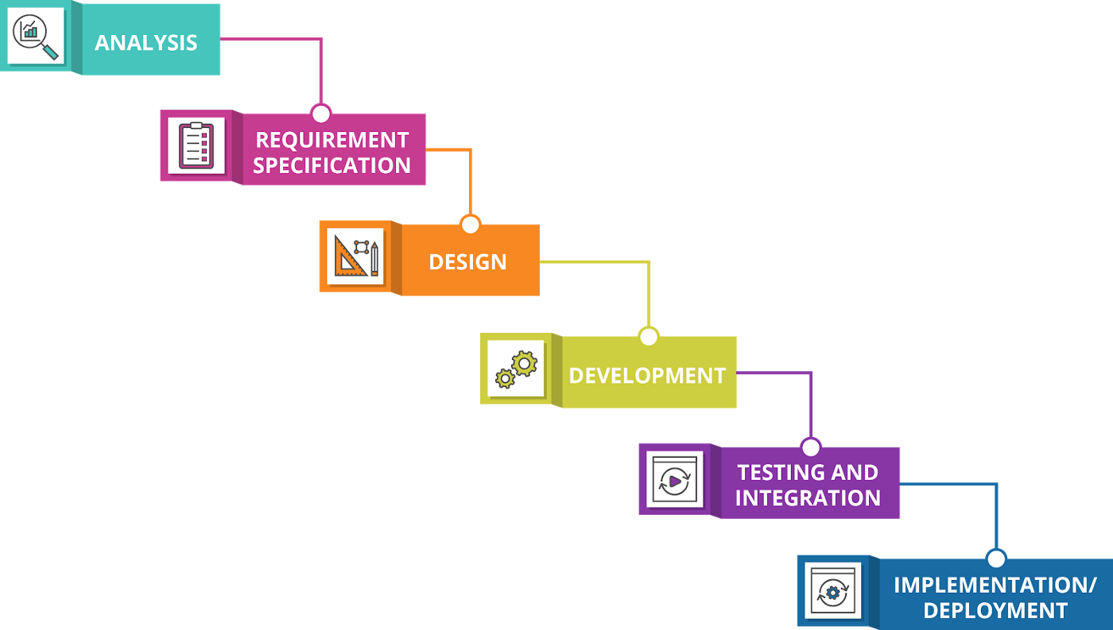

**Prototyping Model.**

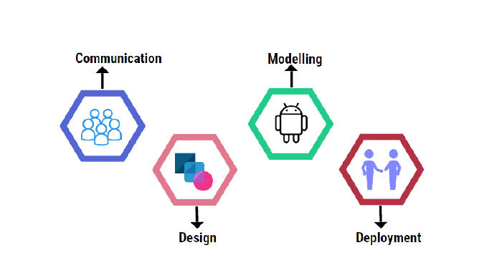

* The prototyping model is a systems development method in which a [prototype](https://searcherp.techtarget.com/definition/prototype) is built, tested and then reworked as necessary until an acceptable outcome is achieved from which the complete system or product can be developed.
* The Prototyping Model is one of the most popularly used Software Development Life Cycle Models (SDLC models).
* This model is used when the customers do not know the exact project requirements beforehand.
* The system is partially implemented before or during the analysis phase thereby giving the customers an opportunity to see the product early in the life cycle.
* The process starts by interviewing the customers and developing the incomplete high-level paper model.
* Once the customer figures out the problems, the prototype is further refined to eliminate them.

**RAD Model.**

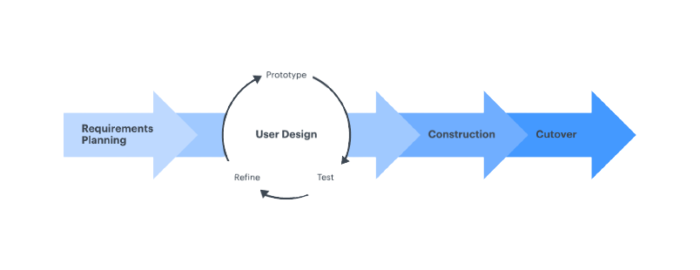

* **RAD Model** or Rapid Application Development model is a software development process based on prototyping without any specific planning.
* In RAD model, there is less attention paid to the planning and more priority is given to the development tasks.
* The **RAD (Rapid Application Development)** model is based on prototyping and iterative development with no specific planning involved.
* Rapid Application Development focuses on gathering customer requirements through workshops or focus groups, early testing of the prototypes by the customer using iterative concept, reuse of the existing prototypes (components), continuous integration and rapid delivery.
* In the RAD model, the functional modules are developed in parallel as prototypes and are integrated to make the complete product for faster product delivery. Since there is no detailed preplanning, it makes it easier to incorporate the changes within the development process.

**Iterative Model.**

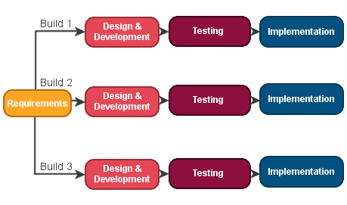

* The iterative model is a particular implementation of a software development life cycle (SDLC) that focuses on an initial, simplified implementation, which then progressively gains more complexity and a broader feature set until the final system is complete.
* When discussing the iterative method, the concept of incremental development will also often be used liberally and interchangeably, which describes the incremental alterations made during the design and implementation of each New Iteration.
* In this Model, you can start with some of the software specifications and develop the first version of the software.
* The Iterative Model allows the accessing earlier phases, in which the variations made respectively. The final output of the project renewed at the end of the Software Development Life Cycle (SDLC) process.
* The iterative model breaks down the software development process of a very big application into smaller pieces.

**Spiral model.**

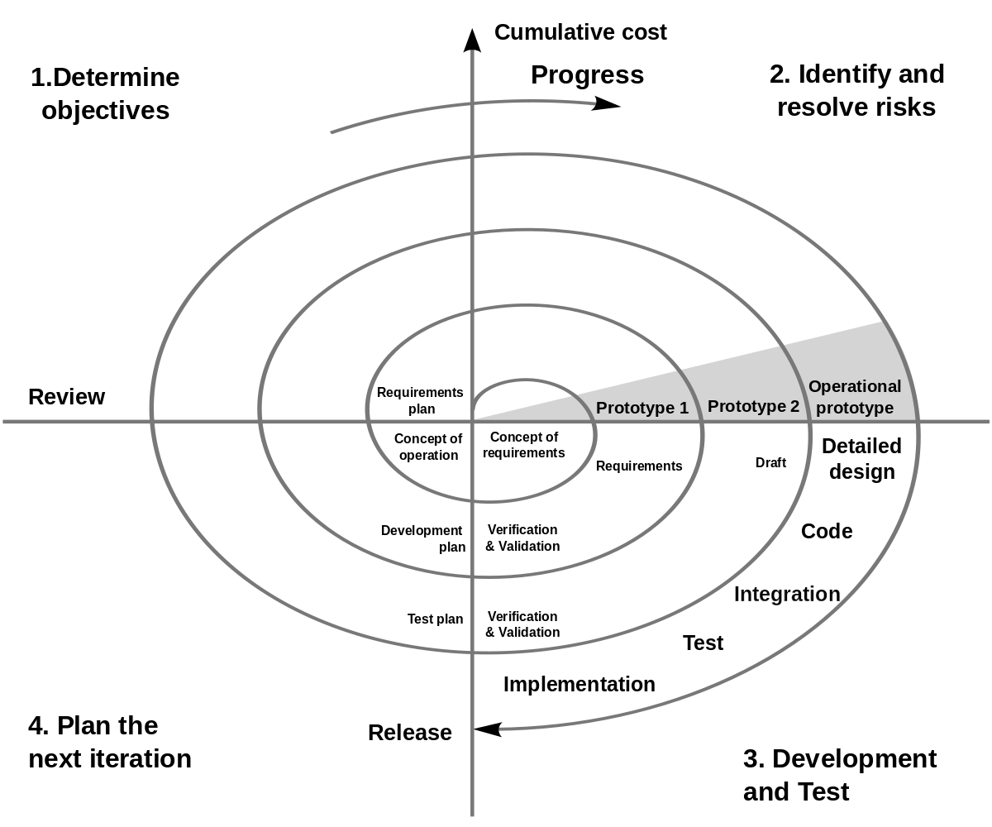

* **Spiral model** is one of the most important Software Development Life Cycle models, which provides support for **Risk Handling**.
* In its diagrammatic representation, it looks like a spiral with many loops. The exact number of loops of the spiral is unknown and can vary from project to project.
* Each loop of the spiral is called a **Phase of the software development process.**
* The exact number of phases needed to develop the product can be varied by the project manager depending upon the project risks.
* The **spiral model** is a risk-driven [software development process](https://en.wikipedia.org/wiki/Software_development_process) model. Based on the unique risk patterns of a given project, the spiral model guides a team to adopt elements of one or more process models, such as [incremental](https://en.wikipedia.org/wiki/Iterative_and_incremental_development), [waterfall](https://en.wikipedia.org/wiki/Waterfall_model), or [evolutionary prototyping](https://en.wikipedia.org/wiki/Software_prototyping#Evolutionary_prototyping).
* The Spiral model is called a Meta-Model because it subsumes all the other SDLC models.

**Diagrams**

**Url Shortner Diagram :-**

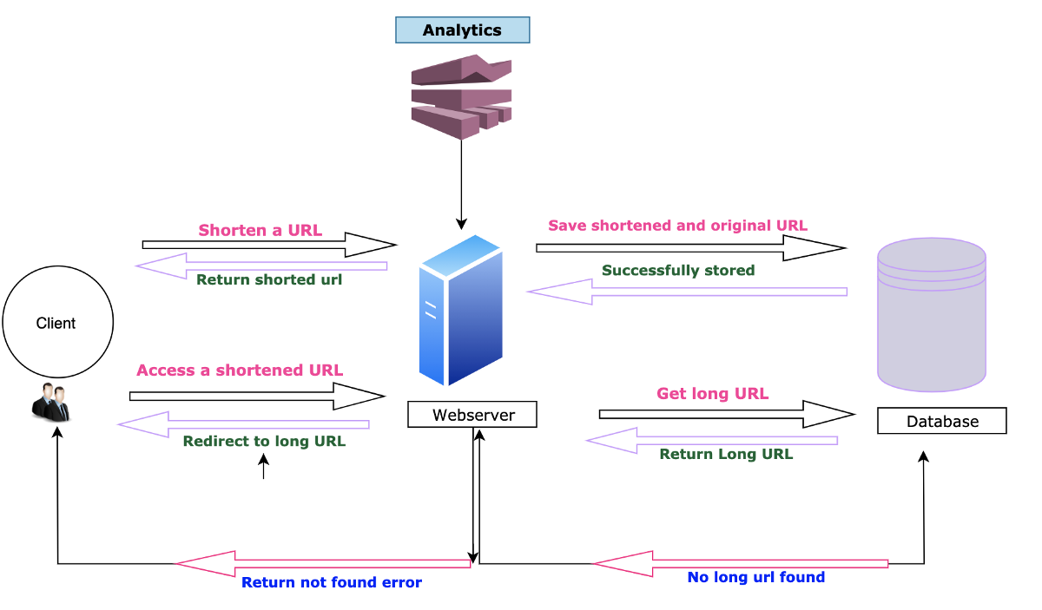

Use case Diagram :-

Activity Diagram

* **Login register diagram :-**

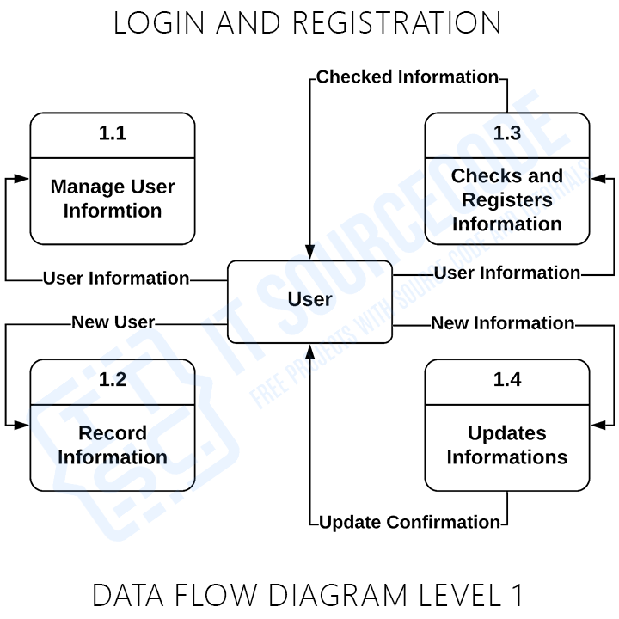

Image compression :-

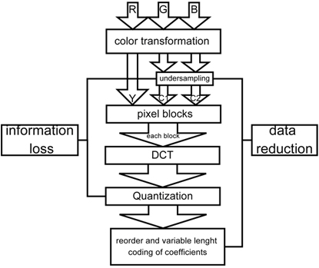

**Data dictionary**

**Table Name :-**

* 1. Admin Table
  2. Url_Shortner Table
  3. Compressor Table
  4. Login Table

1. **Table Name :-** Admin

Primary Key :- id

Description :- Admin table store information about id, name, pass etc..

|  |  |  |  |  |  |
| --- | --- | --- | --- | --- | --- |
| Id | Field_nm | Data_type | Size | Constraints | Description |
| 1. | Id | Int | 30 | Primary key | Id |
| 2. | name | Text | **_** | Not null | Name |
| 3. | username | Varchar | 250 | Not null | Username |
| 4. | password | Text | **_** | Not null | password |

1. **Table Name :-** Url_Shortner

Primary Key :- id

Current_timestamp :- date_created

Description :- this table store information about short url.

|  |  |  |  |  |  |
| --- | --- | --- | --- | --- | --- |
| Id | Field_nm | Data_type | Size | Constraints | Description |
| 1. | Id | Int | 30 | Primary key | Id |
| 2. | code | Varchar | 50 |  | code |
| 3. | url_redirect | Text | ­­_ |  | url_redirect |
| 4. | redirects | Int | 30 |  | redirects |
| 5. | last_browsed | Date Time | _ | Not null | last_browsed |
| 6. | date_created | Date Time | _ | Current_timestamp | date_created |

1. **Table Name :-** Compressor Table

Primary Key :- Img_id

Description :- this table store information about compressed images.

|  |  |  |  |  |  |
| --- | --- | --- | --- | --- | --- |
| Id | Field_nm | Data_type | Size | Constraints | Description |
| 1. | Img_id | Int | 11 | Primary key | Image_Id |
| 2. | Img_name | Varchar | 250 | Not null | Image_Name |
| 3. | Img_desc | Varchar | 250 | Not null | description |

1. **Table Name :-** Login Table

Primary Key :- Id

Description :- this table informed about user login details.

|  |  |  |  |  |  |
| --- | --- | --- | --- | --- | --- |
| Id | Field_nm | Data_type | Size | Constraints | Description |
| 1. | Id | Int | 255 | Primary key | Id |
| 2. | username | Varchar | 255 | Not null | username |
| 3. | Password | Varchar | 255 | Not null | password |

**Input/Output Design**

* **Input design :-**

1. Php
2. MySQL

The input design is the link between the information system and the user. Its developing specification a usable form of processing can be achieved by the computer to read, written or print documents.

* What data should be given as input?
* How the data should be arranged or coded?
* Methods for preparing input validations and steps of follow when error occurs.
* **Output design :-**

1. Browser

A quality output is one, which meets the requirements of the end user and presents the information clearly. In a processing of any system result of processing are communicated to the users and to other system through output. In output design it is determined how the information is to be displayed.

* **Home Page :-**

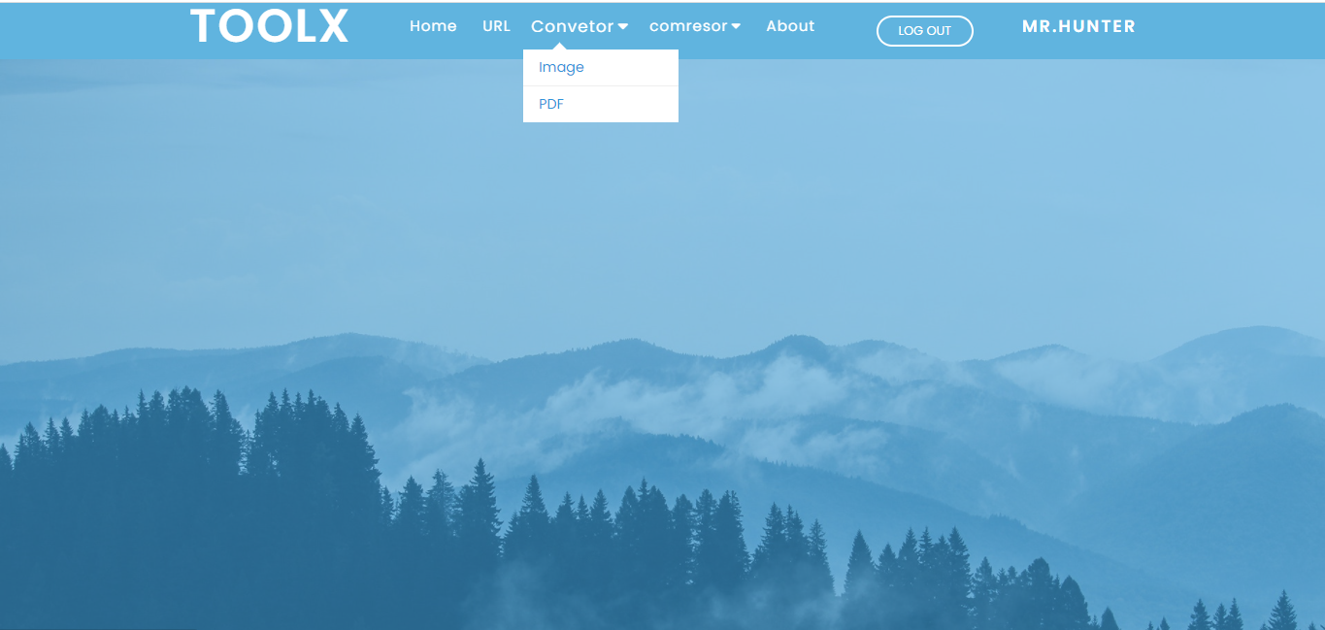

* **This is home page.**
* **Login and signup button.**
* **After login. Log out button displayed.**
* **Url_Shortner Page :-**

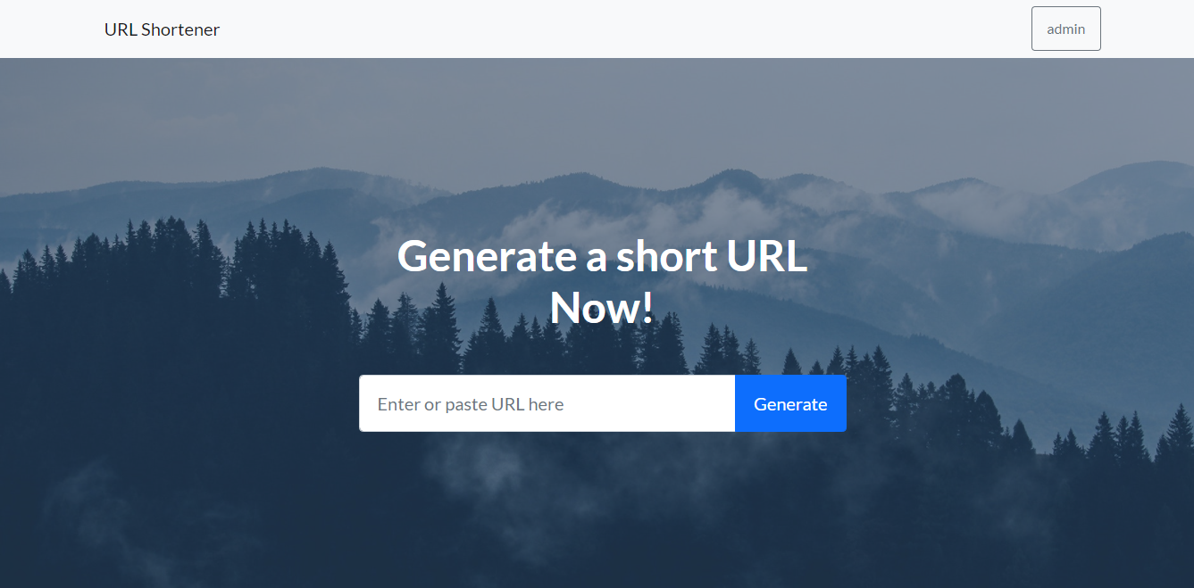

* **Used for the shot url.**
* **How url short Guide in this page.**
* **Show admin panel.**
* **Url Admin Panel :-**

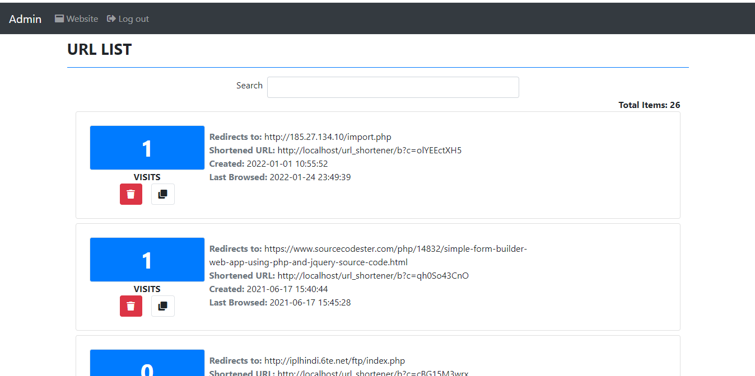

* **Display the all shorted url.**
* **Display time and date when user short the url.**
* **Show the how many times the link was redirect.**
* **Display the how many time url visit by user.**
* **Admin can delete the url.**
* **Image Compressor Page :-**

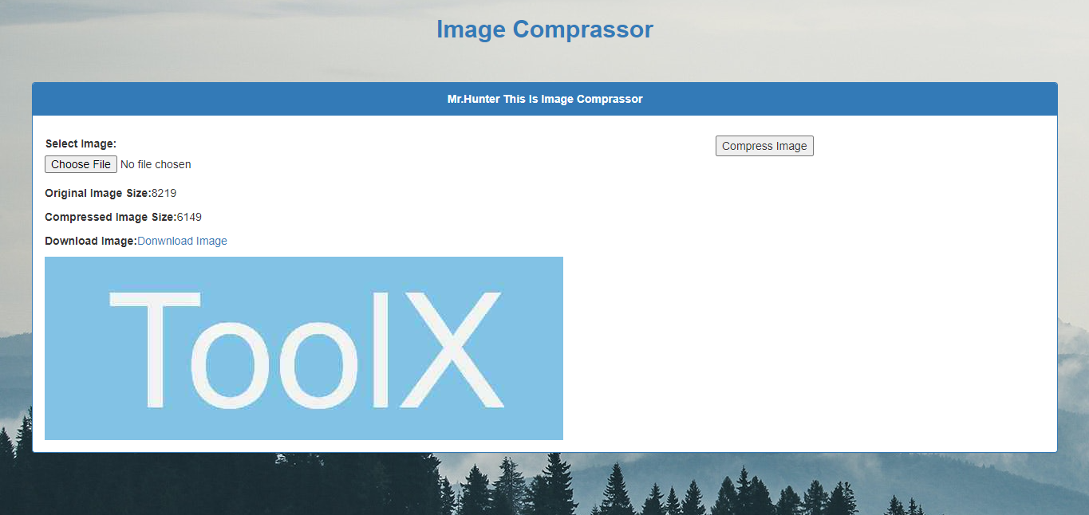

* **Used for the compressor the image.**
* **Show the original size and the compressed size.**
* **Compressor the image without lose quality of image.**
* **Download compressed image.**
* **Show image after compressed.**
* **Image convertor Page :-**

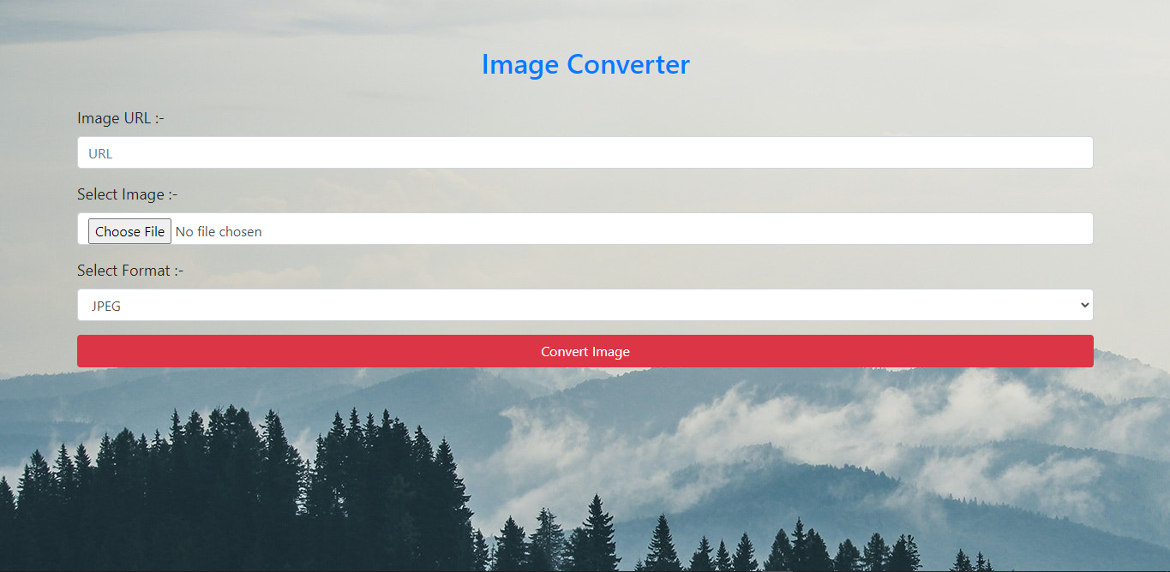

* **Using this tool user can convert their image.**
* **Also can convert image through the image url.**
* **Convert image in jpe, jpeg, gif etc. format.**
* **We can select image from our computer.**
* **About Page :-**

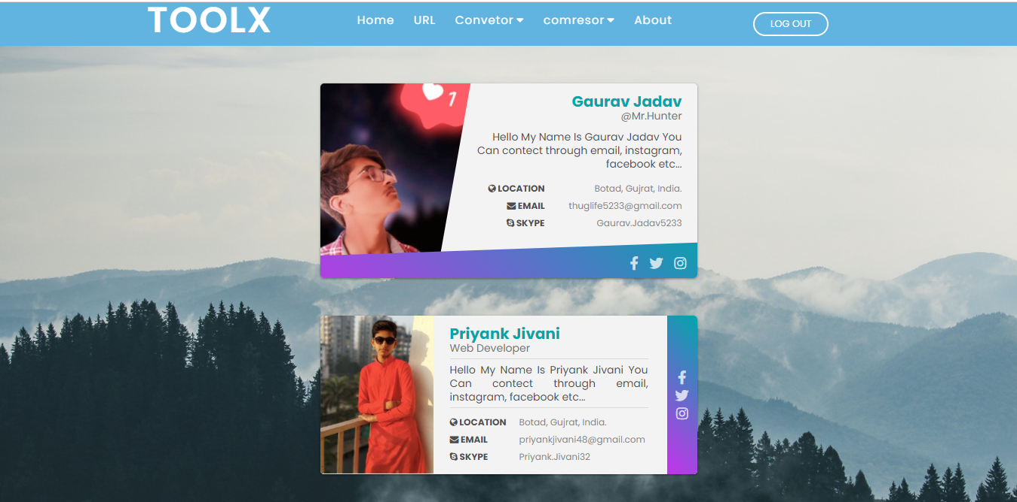

* **Show our profile in this page.**
* **User can contact through the social media.**
* **User can email us.**
* **Showing our portfolios to users.**
* **Signup/Login Page :-**

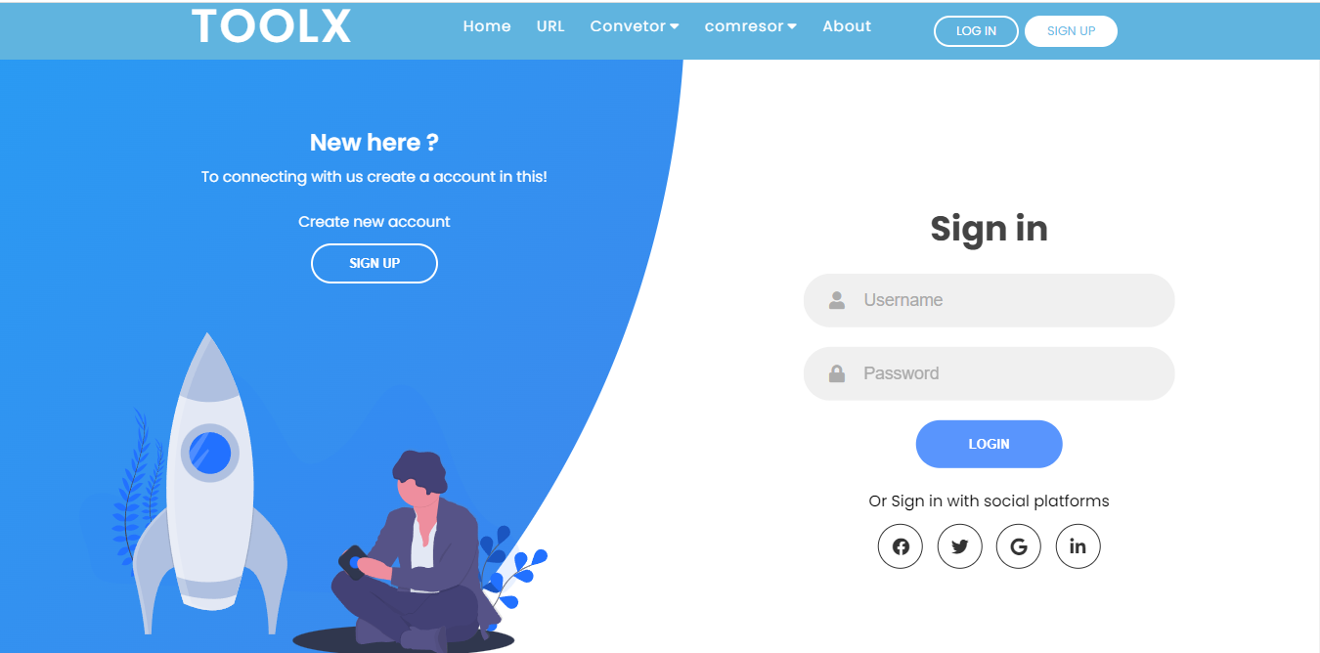

* **Used for the login.**
* **Using Signup create your account in this site.**
* **After login shoe the user user name in navbar.**

Chapter :- 4

Testing

and Implementation

**POINTS**

4.1 Testing

4.2 Testing Approach used

4.3 Test Cases

4.4 Implementation approach

**Testing**

* **Introduction :-**

To be successful, testing will need manage the effectively, generally software testing is relegated to one phase of the software development life cycle. There’s something to be said for including testing in all phase, however.

* **Testing Plan :-**
* **What is software testing?**

Testing involves operation of a system or application under controlled conditions and evaluating the result. The controlled conditions should include both normal and abnormal conditions.

Testing should intentionally attempt to make things go wrong to determine if things happen when they do not happen when they should. It is oriented to ‘detection’.

* **The need for testing :-**

No matter how good programmer is, no application will ever be one hundred percent correct.

Testing was important to us in order to ensure that the application works as efficient as possible and conforms to the need of the system.

Testing was carried out throughout the development of the applications, not just the application has been developed, as at this stage its look like a great deal of effort to fix any bugs or design problems that were occurred.

**Testing Approach used**

**pproach used**

* **Unit Testing :-**
* Unit testing is a software development process in which the smallest testable  
  parts of an application, called units, are individually and independently  
  scrutinized for proper operation.
* The main objective of unit testing is to isolate written code to test and determine  
  if it works as intended.
* Unit testing is an important step in the development process, because if done  
  correctly, it can help detect early flaws in code which may be more difficult to  
  find in later testing stages.
* A unit test typically comprises of three stages: plan, cases and scripting and the  
  unit test itself. In the first step, the unit test is prepared and reviewed. The next  
  step is for the test cases and scripts to be made, than the code is tested.
* **Performance Testing :-**
* Performance testing measures the quality attributes of the system, such as  
  scalability, reliability and resource usage.
* Speed - Determines whether the application responds quickly.
* Scalability - Determines maximum user load the software application can  
  handle.
* Stability - Determines if the application is stable under varying loads.
* Performance engineering. Ability - Determines if the application is stable under  
  varying loads.
* **System Testing :-**
* System Testingis a level of testingthat validates the complete and fully  
  integrated software product. The purpose of a system testis to evaluate the  
  end-to-end systemspecifications. Usually, the software is only one element of  
  a larger computer-based system.
* Different types of tests (GUI testing, Functional testing,  
  Regression testing, Smoke testing, load testing, stress testing,  
  security testing, stress testing, ad-hoc testing etc.,) are carried out to  
  complete system testing.
* System testing is the type of testing to check the behavior of a complete and  
  fully integrated software product based on the software requirements  
  specification (SRS) document. The main focus of this testing is to evaluate  
  Business / Functional / End-user requirements.
* **Security Testing :-**
* Security Testingis a type of Software Testing that uncovers  
  vulnerabilities, threats, risks in a software application and prevents malicious  
  attacks from intruders.
* The purpose of Security Tests is to identify all possible loopholes and  
  weaknesses of the software system which might result in a loss of information,  
  revenue, repute at the hands of the employees or outsiders of the Organization.
* The goal of security testing is to identify the threats in the system and measure  
  its potential vulnerabilities, so the system does not stop functioning or is  
  exploited.
* It also helps in detecting all possible security risks in the system and help  
  developers in fixing these problems through coding.

**Test Cases**

**pproach used**

* In software engineering the most common definition of a test case is a set of conditions or variables under which a tester will determine if a requirement or use case upon an application is partially or fully or satisfied. It may take many test cases to determine that requirement is fully satisfied. In order to fully test that all requirement of an application are met.
* **Common Test :-**

|  |  |  |  |
| --- | --- | --- | --- |
| **No.** | **Test Case** | **Expected Result** | **Actual Result** |
| 1. | Check textbox for validation. | Test, with all validation is inserted | Pass |
| 2. | Check tab order | It should be in proper logical order and it should move through all the field | Pass |
| 3. | Check heading titles of all the pages. | There should be no grammatical mistake or spelling mistake. All the heading and title should be consistent throughout the system. | Pass |
| 4. | Field validation | Proper validation should be placed according to the program specification to validate the required field and to check the type of allowed characters.  Spaces should be trimmed as per general standard. | Pass |
| 5. | Check field name, type, size, for each database table and against database design | Field name, type and size should be consistent throughout the database for a particular file | Pass |
| 6. | Select value from the dropdown combo box | the dynamic value from the database should be field in the dropdown combo box | Pass |
| 7. | Delete the record any try to field in the database | Record must be deleted from the database and should not be available there. | Pass |

* **Sign in Test :-**

|  |  |  |  |
| --- | --- | --- | --- |
| **No.** | **Test Case** | **Expected Result** | **Actual Result** |
| 1. | Try to login with empty field in the username and password test boxes. | An error message is displayed “username” is required “password” is required. | Pass |
| 2. | Enter invalid username and password | An error message displayed “invalid username or password”. | Pass |
| 3. | Click on any feature on website | On click on any feature, check whether the user has logged in or no.  Otherwise it redirect in login page. | Pass |

**Implementation approach**

**pproach used**

* **Black-Box Testing :-**
* Black-box testing also called behavioral focuses on the functional requirements of the software.
* That is black-box testing enables the software engineer to device sets of input conditions that will fully exercise all functional requirements for a program.
* Black-box testing is not an alternative to white-box techniques.
* Rather, it is complementary approach that is likely to uncover a different class of errors than white-box methods.
* Black-box testing attempts to find errors in the following categories:

1. incorrect or missing functions

2. interface errors

3. errors in data structures or external data base access

4. behavior or performance errors, and

5. Initialization and termination errors.

**Advantages of Black-Box Method :-**

* Well suited and efficient for large code segments.
* Code access is not required.
* Clearly separates user's perspective from the developer's perspective through visibly defined roles.
* Large numbers of moderately skilled testers can test the application with no knowledge of implementation, programming language, or operating systems.

**Disadvantages of Black-Box Method :-**

* Limited coverage, since only a selected number of test scenarios is actually performed.
* Inefficient testing, due to the fact that the tester only has limited knowledge about an application.
* Blind coverage, since the tester cannot target specific code segments or error-prone areas.
* The test cases are difficult to design.
* **Black-Box & White-Box Testing :-**

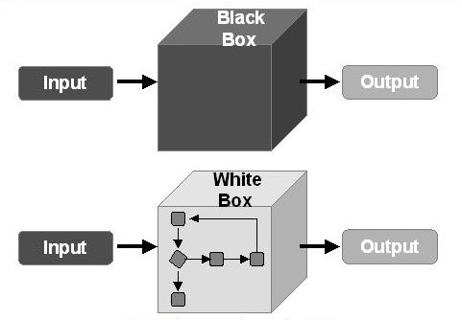

* **White-Box Testing :-**
* White-box testing is concerned with testing the implementation of the program.
* The intent of this testing is to exercise the different programming structures and data structures used in the program.
* White-box testing is also called structural testing.
* White-box testing, sometimes also called glass-box testing is a test case design method that uses the control structure of the procedural design to derive test cases.
* Using white-box testing methods, the software engineer can derive test cases that
* Guarantee that all independent paths within a module have been exercised at least once,
* exercise all logical decisions on their true and false sides,
* Execute all loops at their boundaries and within their operational bounds, and
* Exercise internal data structure to ensure their validity.
* While white box testing can be applied at the unit, integration and system levels of the software testing process, it is usually done at the unit level.

**Advantages of White-Box Method :-**

* As the tester has knowledge of the source code, it becomes very easy to find out which type of data can help in testing the application effectively.
* It helps in optimizing the code.
* Extra lines of code can be removed which can bring in hidden defects.
* Due to the tester's knowledge about the code, maximum coverage is attained during test scenario writing.

**Disadvantages of White-Box Method :-**

* Due to the fact that a skilled tester is needed to perform white-box testing, the costs are increased.
* Sometimes it is impossible to look into every nook and corner to find out hidden errors that may create problems, as many paths will go untested.
* It is difficult to maintain white-box testing, as it requires specialized tools like code analyzers and debugging tools.

Chapter :-5

Conclusion

**POINTS**

1.1 Conclusion

1.2 Limitation of system

1.3 Future Scope of system

1.4 Bibliography

**Implementation approach**

**pproach used**

* While researching the topic I found a couple of references that had a idea for making tools combinations website. The first thing I would recommend is to